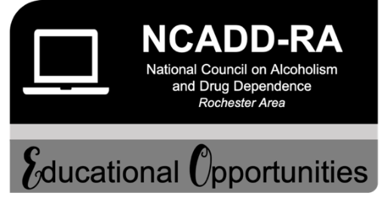
Join us for
Distance Learning Opportunity
November Series
________________________________________________________________________________________________

Personal and Professional Wellness for Addictions Professionals  Presenter: Keith Greer, LCSW  Date: Thursday & Friday, November 5 & 6, 2020  Time: 9:00 AM – Noon (Both Days)  Cost: $65  Content: Through a highly interactive format, this workshop will explore the stressors of working in the addictions field. Participants will gain an understanding of how to create behavior that aligns with personal and professional values, aspirations and goals. Other topics include small choices vs. huge goals and identifying who or what depletes a “sense of responsibility” from a “response-ability.” | 6 Clock Hours:  CASAC Renewal  CPP Section 3  CPS Section 3  LMHC  Registration deadline:  Thursday, October 29, 2020  Training Location:  Zoom Platform  Click on the link below to register:  https://ncadd-ra.org/events-trainings/

Working Effectively with Adolescents and Young Adults Struggling with Substance Use Disorders  Presenter: April Aycock, PhD, LMHC, Master-CASAC  Date: Friday, November 13, 2020  Time: 9:00 AM – Noon  Cost: $35  Content: According to the 2019 Monitoring the future survey, teen drug and alcohol use has declined except for marijuana and vaping usage. Yet youth are continuing to use drugs and alcohol, teenagers become adults, and addiction does not always go away with age. Discussed will be effective ways to engage adolescents and young adults struggling with substance use as well as ways to engage families and friends when working with adolescents and young adults. Understanding how to identify barriers for clients and the therapist will also be discussed. | 3 Clock Hours  CASAC Renewal  CPP Section 2  CPS Section 2  LMHC  Registration deadline:  Friday, November 6, 2020  Training Location:  Zoom Platform  Click on the link below to register:  https://ncadd-ra.org/events-trainings/

Using Motivational Interviewing to Enhance the Spirit of Recovery  Presenter: Anthony R. Klein, MPA, CASAC, NCACII  Date: Wednesday, November 18, 2020  Time: 9:00 AM – Noon  Cost: $35  Content: This virtual workshop provides an introduction to Motivational Interviewing, a collaborative, goal-oriented style of communication with particular attention to hope-inducing language of change. Participants will learn engagement strategy that includes ways to support client autonomy, foster a spirit of hope, elicit and reinforce change talk, develop a behavior change plan, and consolidate client commitment to their program of drug recovery. | 3 Clock Hours  CASAC Renewal  CPP Section 1  CPS Section 1  LMHC  Registration deadline:  Wednesday, November 11, 2020  Training Location:  Zoom Platform  Click on the link below to register:  https://ncadd-ra.org/events-trainings/

Additional Information:
• Link to training will be e-mailed upon successful registration 24 hours prior to training.
• PDF of handouts will be e-mailed 24 hours prior to training.
• Quiz and Evaluation form will be provided at the end of the training.
• Certificate will be issued upon receipt of passing quiz (70% or higher) and completed evaluation.

For more information, please call or e-mail Elaine Alvarado at (585) 719-3481, ealvarado@depaul.org or Amy Johnson at (585) 719-3489, ajohnson@depaul.org.

St. John Fisher College is recognized by the New York State Educational Department’s State Board as an approved provider of continuing education credits for Licensed Mental Health Counselors.

