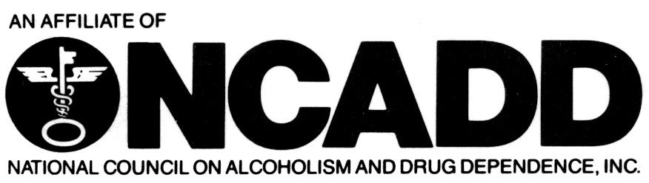
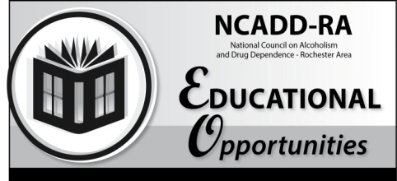

National Council on Alcoholism and Drug Dependence – Rochester Area
Overview of FASD: Prevention, Intervention and Diagnostic Perspectives
Presenters – Lynn Cole, PNP; Christie Petrenko, Ph.D.; Jennifer Faringer, MS.Ed., CPPg
Date: Wednesday, March 28, 2018
3 Clock Hours
CASAC Renewal
CPP Section 1
CPS Section 1

Time: 9:00 a.m. – Noon (Registration will begin at 8:30 a.m.)
Cost: $35

Content: This workshop will explore aspects of Fetal Alcohol Spectrum Disorder from prevention to intervention to diagnosis. Discussed will be cause and prevalence, alcohol exposure related to phases of development, recommendations and strategies for educators and counselors as well as educational and support resources. We will also discuss the models of intervention, from theoretical to lived experience, as well as the efficacy of interventions across the age groups. Diagnostic challenges will be explored looking at overlapping symptomology using case studies.
Registration Deadline: Wednesday, March 21, 2018
Training Location - DePaul’s NCADD-RA
1931 Buffalo Road, Rochester, NY 14624
Continental breakfast is provided.
--------------------------------------------------------------------------------------------------------------------------------------------------------
Training Date/Title: Wednesday, March 28, 2018/ Overview of FASD: Prevention, Intervention and Diagnostic Perspectives- Deadline: Wednesday, March 21, 2017
Name: _____________________________________________ Job Title: ________________________________

Employer: ___________________________________________ Telephone: ______________________________

Address: ______________________________________________________________________________________

E-mail: ________________________________________________________________________________________

Return form with a $35 NON-REFUNDABLE registration fee to:

DePaul NCADD-RA

1931 Buffalo Rd

Rochester, NY 14624
(585) 719-3481
(585) 423-1908 fax
ncadd@depaul.org e-mail
www.ncadd-ra.org

NCADD-RA, Attention: Elaine Alvarado 1931 Buffalo Rd., Rochester, NY 14624
For more information, please call or e-mail Elaine at (585) 719-3481,
ealvarado@depaul.org or Shelly Budinski at (585) 719-3489, sbudinski@depaul.org.
**Please complete payment information on reverse**
Please note training policy on reverse. Registration confirmation will not be sent. However,
in the event this training must be canceled or relocated, be sure to include complete contact
information for notification purposes.

Online registration also available at www.ncadd-ra.org.

