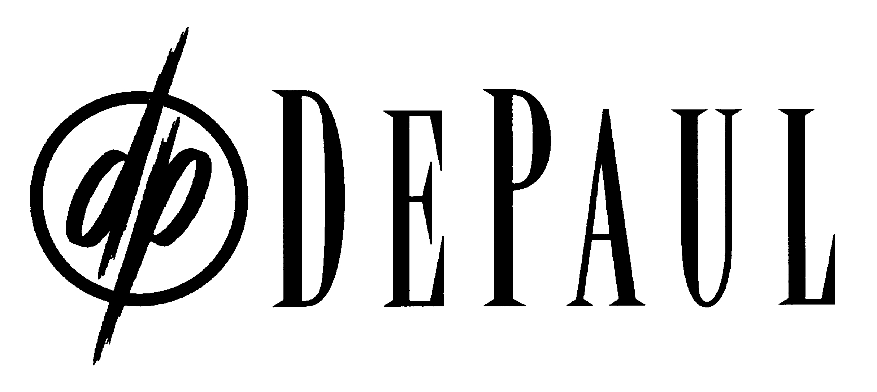
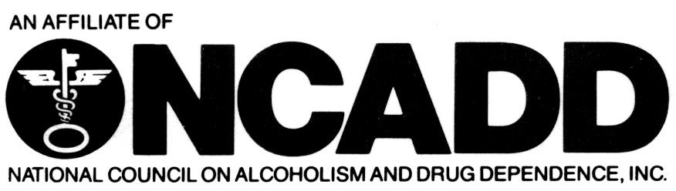
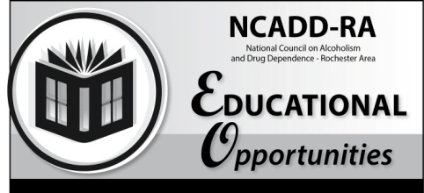

National Council on Alcoholism and Drug Dependence – Rochester Area
Overview of DSM 5
Presenter – Nancy Crowley, CSW, CASAC
Date: Friday, February 9, 2018
6 Clock Hours
CASAC Renewal Only
CPP Section 4
CPS Renewal Only

Time: 9:00 a.m. – 4:00 p.m. (Registration will begin at 8:30 a.m.)
Cost: $65

Content: Participants will become familiar with the DSM 5 to include an understanding of Multiaxial Assessment. Participants will learn techniques for using the DSM 5 in their clinical work in a chemical dependency treatment program. Additionally we will explore the similarities and differences between the new DSM 5 and the prior DSM IV TR.
Registration Deadline: Friday, February 2, 2018
Training Location - DePaul’s NCADD-RA
1931 Buffalo Road, Rochester, NY 14624
Continental breakfast is provided. Please make your own lunch arrangements.
----------------------------------------------------------------------------------------------------------------------------------------------------------
Training Date/Title: Friday, February 9, 2018– Overview of DSM 5
Deadline: Friday, February 2, 2018
Name: _____________________________________________ Job Title: ________________________________

Employer: ___________________________________________ Telephone: ______________________________

Address: ______________________________________________________________________________________

Fax/email: _____________________________________________________________________________________

Return form with a $65 NON-REFUNDABLE registration fee to:

DePaul NCADD-RA

1931 Buffalo Rd

Rochester, NY 14624
(585) 719-3481
(585) 423-1908 fax
ncadd@depaul.org e-mail
www.ncadd-ra.org

NCADD-RA, Attention: Elaine Alvarado 1931 Buffalo Rd., Rochester, NY 14624
For more information, please call or e-mail Elaine at (585) 719-3481,
ealvarado@depaul.org or Shelly Budinski at (585) 719-3489, sbudinski@depaul.org.
**Please complete payment information on reverse**
Please note training policy on reverse. Registration confirmation will be sent via e-mail ONLY.
In the event this training must be canceled or relocated, be sure to include complete contact
information for notification purposes.

You may also register online at www.ncadd-ra.org

